There are many positive points about the EasyJet website. The layout is clean and easy to both use and navigate. The different price zones are clearly indicated and highlight when the users mouse is in the zone on the plane. The user is also able to click a more button to see what is included in the additional price they are going to pay. Once a seat has been selected, the user get visual feedback in three ways; the seat changes colour, the icon of a person sits down, and the seat number is displayed below the seated icon. I also like the fact that EasyJet’s continue button isn’t active until all the seats have been selected and saved. One negative I can think of on the EasyJet website, is that the final price is not updated until the user saves the seats and presses continue.

On the Squeezyjet website, the layout is centred with the flight and booking information, as well as the key aligned to the right of the page but within the centred layout. I like that the selected seats and the taken seats are a different colour form the seats that are free and that the key makes this easy to understand. I like that the user knows when they have booked all four seats but would have liked the user to be able to see what seat numbers they have booked. I would have liked the arrival time to be the time for the local airport rather than GMT and this should have been made clear to the user. It would have been benificial if the seats added on an additional price and that the price would be added to the subtotal when selected.

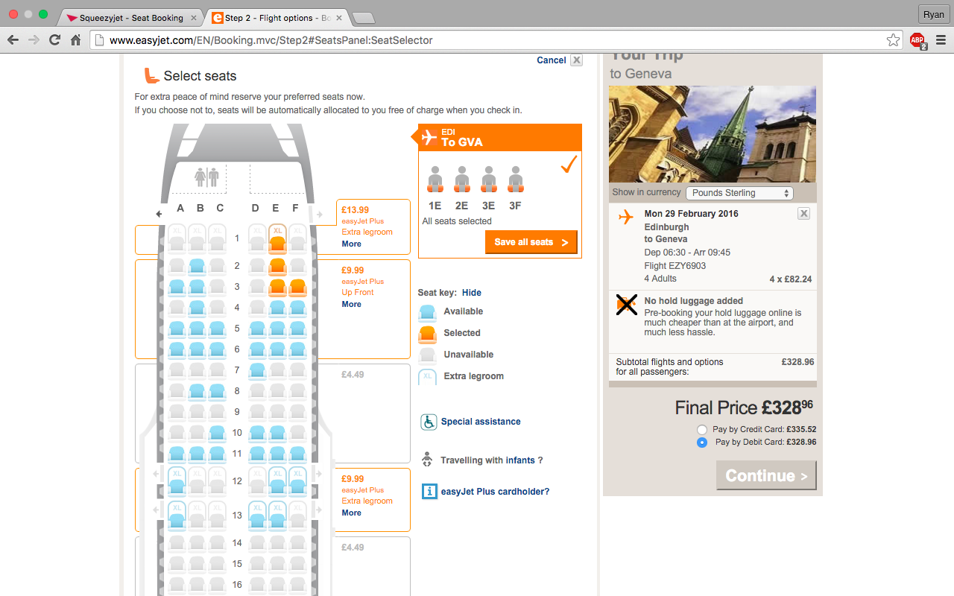Screen shots of both sites can be seen below:

